Neve digital sector pack
We're thrilled to have your support for Neve, a new website designed to empower women, girls, feminine-identifying, and non-binary people with disabilities across Australia. Please help us spread the word!
To make sharing easy, we've prepared a pack with:
- A brief overview of Neve: Learn about the website's mission and key messages.
- Sample copy for your email: Use our ready-made text in your next newsletter (or create a special edition dedicated to Neve!).
- Social media posts and tiles: Share eye-catching visuals and key messages across your digital channels.
Feel free to use these resources as-is, or craft your own unique message about why Neve is a crucial step forward for women with disabilities in Australia.
Background to the project
Neve is a groundbreaking website created by and for women, girls, feminine-identifying, and non-binary people with disabilities in Australia. Born from two years of extensive consultation and collaboration, it addresses the community's unique needs for accessible information and support.
Building on the foundation of "Our Site," Neve offers an expanded resource on over 70 topics, with a special focus on violence prevention, safety, rights, and empowerment. It provides clear guidance on recognising abuse, navigating dangerous situations, and seeking help.
Neve sets a new standard for accessibility in Australia by prioritising Easy Read formatting and offering key sections in various languages. It is also available in plain English and accessible formats like text-to-speech and large text.
This platform serves as a safe and inclusive space for the community to access information, share stories, and connect. It encourages feedback and welcomes personal stories for publication, fostering a sense of belonging and empowerment.
Developed and maintained by Women With Disabilities Australia (WWDA) with funding from the Department of Social Services, Neve represents a significant step forward in supporting and empowering women and gender-diverse individuals with disabilities.

Key messages of Neve:
- A safe and accessible online space created by and for women, girls, feminine-identifying, and non-binary people with disabilities.
- A welcoming community where shared experiences are explored and understood.
- A reliable source of information on staying safe, self-care and wellbeing, and healthy relationships.
- A comprehensive resource with over 70 topics relevant to our entire community, including families, supporters, and professionals.
- An advocate for the rights of women, girls, feminine-identifying, and non-binary people with disabilities with disabilities to live free from violence and discrimination, and to make their own choices about their lives, bodies, and relationships.
- A platform built by our community, for our community. Your feedback and personal stories are always welcome.
Sample copy for your email
This is an example of how you could share the news about Neve with your contacts in your next email.

Subject: Introducing Neve: A Safe Space for Women and Non-Binary People with Disabilities
We're thrilled to introduce Neve, a groundbreaking website designed by and for women, girls, feminine-identifying, and non-binary people with disabilities. Neve is a safe and welcoming space focused on violence prevention and safety, offering information and support on over 70 topics.
We know that women, girls, feminine-identifying, and non-binary people with disabilities face unique challenges when seeking help for domestic and family violence. That's why Neve provides accessible resources on identifying abuse, navigating difficult situations, and finding support. You'll also find sections on wellbeing, healthy relationships, and self-care, all designed to empower and uplift.
Neve features powerful stories from our community, sharing their experiences and insights. We've also included resources for family, friends, and professionals who support people with disabilities.
Created by Women With Disabilities Australia (WWDA), Neve is co-designed for maximum accessibility. It's available in Easy Read, plain English, text-to-speech, large text, and various languages.
We need your help. Please check out Neve and share it with your networks. Your feedback is invaluable as we continue to improve this vital resource. If you have a story to share, we encourage you to get in touch with WWDA directly.
Together, we can create a safer and more inclusive world for everyone.
Explore Neve: https://www.neve.wwda.org.au/
Social media posts and tiles
Please feel free to use these messages, vary them or use your own words to share Neve on your social media channels. And please tag us!
LinkedIn: @Women with Disabilities Australia (WWDA)
Facebook: @WWDA.Australia
Instagram: @wwda_au
X (Twitter): @WWDA_AU

LinkedIn
Introducing Neve: A groundbreaking new resource from Women with Disabilities Australia (WWDA), co-designed by and for women, girls, feminine-identifying, and non-binary people with disabilities.
Neve is an accessible website providing vital information on over 70 topics, including:
- Staying safe: Empowering women with knowledge to recognise and prevent violence.
- Self-care and wellbeing: Promoting mental and physical health for a fulfilling life.
- Healthy relationships: Fostering positive connections and self-discovery.
We know that women with disabilities face higher rates of violence. Neve aims to bridge the information gap and make a real difference.
Please join us in spreading the word and supporting this fantastic resource. Together, we can create a safer and more inclusive world for all women.
Explore Neve: neve.wwda.org.au/
#Neve #WomenWithDisabilities #Accessibility #ViolencePrevention #Wellbeing #HealthyRelationships
Facebook
Introducing Neve a fantastic new resource co-designed by created by and for women, girls, feminine-identifying, and non-binary people with disabilities. This exciting and accessible website offers a wealth of information on over 70 crucial topics, including:
Staying safe: Equipping women with the knowledge and tools to identify and prevent violence.
Self-care and wellbeing: Nurturing mental and physical health for a fulfilling life.
Healthy relationships: Fostering positive connections and self-discovery.
We understand that women with disabilities are disproportionately affected by violence. That's why Neve is here to provide accessible and approachable information that can make a real difference.
Please help us spread the word! Share this post with your friends, family, and networks. Let's work together to ensure every woman, girl, feminine-identifying, and non-binary person with disabilities has access to being supported, informed, and empowered.
Explore Neve: neve.wwda.org.au/
#Neve #WomenWithDisabilities #Accessibility #ViolencePrevention #Wellbeing #HealthyRelationships

Instagram
Introducing Neve: A groundbreaking new resource from Women With Disabilities Australia (WWDA), co-designed by and for women, girls, feminine-identifying, and non-binary people with disabilities.
Neve is a groundbreaking website designed by and for women with disabilities, providing essential resources and support on a wide range of topics:
Staying safe, wellbeing, selfcare and healthy relationships
Whether you're a woman with a disability, a friend, family member, or professional, Neve has something for you!
Head over to @wwda_au for more information and check out Neve today! Together, let's create a more inclusive and empowering world for all women, girls, feminine-identifying, and non-binary people with disabilities.
Twitter
Neve is a groundbreaking website designed by and for women, girls, feminine-identifying, and non-binary people with disabilities providing essential resources and support on a wide range of topics including staying safe, self-care and wellbeing and healthy relationships. There are resources available for friends, family, and professionals as well - explore Neve: neve.wwda.org.au/
#Neve #WomenWithDisabilities #Accessibility #ViolencePrevention #Wellbeing #HealthyRelationships

One last thing! Thursday, 16 May 2024, is also Global Accessibility Awareness Day (GAAD). This is a brilliant resource to share on this day. If you share it as a part of GAAD, you can use the hashtag #GAAD!

Social Media tiles
Please feel free to use this image with any of the above content and always include an image description.

Image description: Image with a purple background and a white Neve logo. The Neve logo is the word neve with petals like a flower underneath it. White text at the bottom of the image says Available now neve.wwda.org.au.
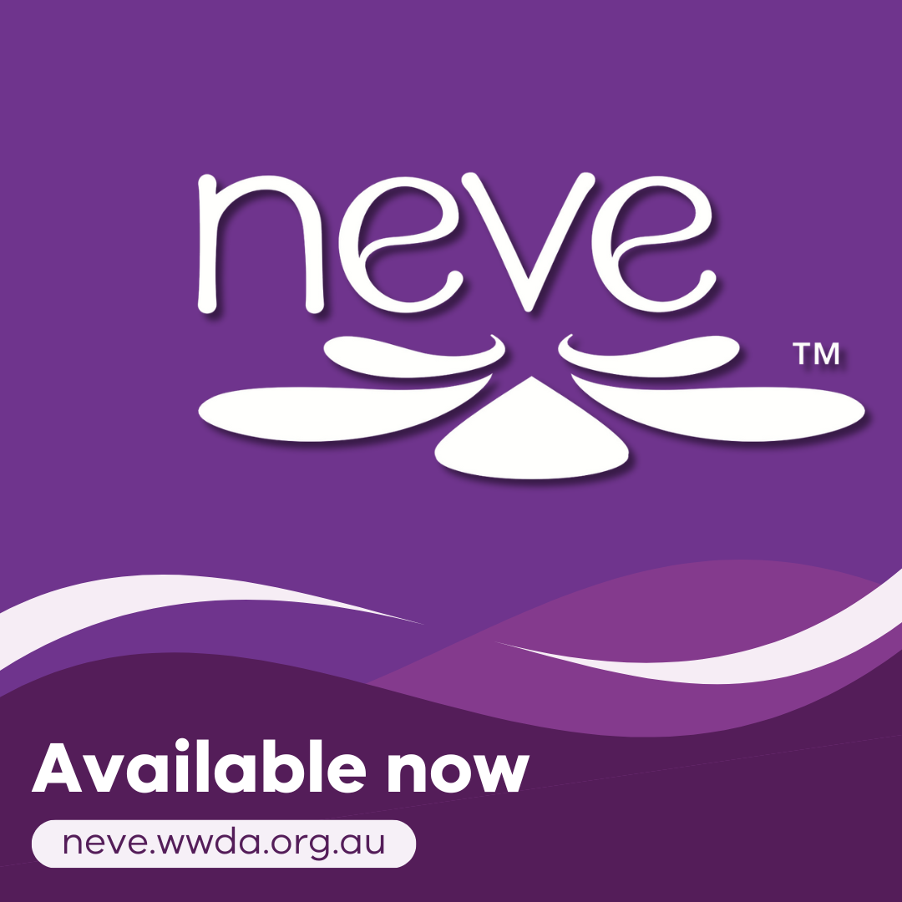

Thank you for your ongoing support.
With excitement,
Neve Project Team WWDA

